Forecast-Driven Model Predictive Control with Reinforcement Learning for Low-Carbon Community Battery Scheduling
Elena Margaret Ellis  School of Computer Science  and Engineering  Vellore Institute of Technology  Chennai, India  elenamargaret.ellis2023@vitstudent.ac.in | Anora V  School of Computer Science  and Engineering  Vellore Institute of Technology  Chennai, India  anora.v2023@vitstudent.ac.in | Cherish Vasant  School of Computer Science  and Engineering  Vellore Institute of Technology  Chennai, India  cherish.vasant2023@vitstudent.ac.in | Dr. Natarajan B  School of Computer Science  and Engineering  Vellore Institute of Technology  Chennai, India  natarajan.b@vit.ac.in
Abstract—Residential batteries can contribute to the reduction of electricity costs and emissions by rescheduling energy consumption. However, a controller of any battery system in a building is not equipped to be able to predict future electricity demand, solar generation or carbon intensity. This work proposes a Reinforcement Learning (RL) based model predictive controller for the batteries of an entire district. The load and solar outputs for every building are predicted by gradient-boosted forecasters. Using these forecasts, a linear program plans the battery usage for the next 30 hours. An RL agent is trained using Truncated Quantile Critics (TQC) and a reward function based on the official performance metric. Every hour the agent utilizes the district-level data to compute the three program weights. In the CityLearn Challenge 2022 benchmark of 17 buildings, the controller reduced the electricity cost by 34.4 percent and emissions by 22.1 percent in the training district. It achieved a mean public score of 0.774 and private score of 0.843 in Phase III, placing it at the 8th place among 42 public entries. Its carbon score of 0.764 was the lowest among all 42 entries. It is demonstrated through ablation studies that the optimiser, the forecasts and the RL tuning all contribute to the overall performance.
Index Terms—Smart Grid, deep reinforcement learning, model predictive control, truncated quantile critics, load forecasting, reward function design, CityLearn, carbon emission control.

I. INTRODUCTION
Buildings account for a large share of total electricity consumption. By installing photovoltaic (PV) panels on rooftops and home batteries, buildings have been turned into flexible grid resources. Batteries can reduce emission and electricity costs by charging when carbon intensity and electricity prices are lower. The net demand of electricity from the grid is stabilized when this is implemented across many buildings across a district [1], [2]. The control problem is an issue as each decision affects the battery's state of charge and also its performance over the next several hours. Hence, it becomes difficult to determine how much each action contributed to the final outcome.
Rule-based controllers are simple and therefore struggle to adapt to the weather, the tariff or the state of the grid. Model predictive control (MPC) plans future actions based on the forecasts. However, its performance highly depends on the accuracy of its forecasts and on predefined weights that balance electricity costs, emissions and grid impact. Through multiple interactions with the environment the model-free deep reinforcement learning (RL) [3] learns a policy [4], [5]. The daily patterns of price and demand, and the long-term effect of each charge decision are learned from scalar rewards. The CityLearn environment [6], [7] and the NeurIPS 2022 CityLearn Challenge [8] provide a common benchmark for this problem. The evaluation score depends on the electricity costs, carbon emissions and two grid key performance indicators (KPIs).
This work combines the two ideas in an RL-tuned MPC (Fig. 1). The electricity demand and production capacity are predicted by gradient-boosting models. Then, a linear program uses these predictions and generates battery schedules by taking into account battery constraints. The TQC agent optimizes three weights of the program every hour. Since the inputs are provided at the district level, the same policy can be applied to districts of different sizes. The second contribution is a counterfactual reward function which is aligned with the official evaluation metrics. The function evaluates the difference in metrics in scenarios where batteries are used and not used. The controller is evaluated on all 17 challenge buildings with the official formulas over five seeds. The results are then compared with all 42 public leaderboard entries and the private medians. Through ablation experiments the contributions of each component are evaluated and the forecasting errors with the highest impact on the final score are identified.

II. LITERATURE REVIEW

A. RL for Building Energy and CityLearn
Vázquez-Canteli and Nagy [1] found through most RL studies that simple function approximators, single buildings and custom simulators were used for demand response and hence made their results difficult to compare. Later surveys [2], [4] identified sample efficiency, safety, reward design and transfer across buildings as the main open problems. Nagy et al. [5] emphasized the need for shared benchmarks and KPIs. Multiple problems on real-world RL were listed by Dulac-Arnold et al. [9]. Among them multi-objective rewards, partial observability and limited data are applicable to battery control. PV and storage for buildings are provided by CityLearn [6], [7]. MARLISA [10] coordinated multiple agents through sequential action selection. Real-world challenges of multi-agent RL were studied by Nweye et al. [11] in such communities.

B. Forecast-Driven Optimisation in the CityLearn Challenge
MPC utilizes forecasting to optimize the decisions in the future but implements the first decision and then repeats the process [12]. All the top entries of the 2022 challenge combined forecasting with optimisation [13]. The winner, Together, employed forecasting of the demand for electricity and the PV generation through gradient-boosted trees and linear models. It then combined a rolling-horizon stochastic optimization method with multi-agent Proximal Policy Optimization (PPO). In contrast, the runner-up used dynamic programming and a small policy network trained by CMA-ES. CUFE solved a 24-hour linear program per building, while DivMARL utilized a Soft Actor-Critic (SAC) policy along with a rule-based system driven by the predictions of XGBoost.

C. Deep RL Algorithms and Reward Design
Actor-critic methods are the first preference as MPC weights are continuous. Both DDPG [14] and TD3 [15] learn deterministic policies with off-policy critics. SAC [16] adds an entropy term with automatic temperature tuning to encourage exploration. PPO [17] is a common on-policy alternative. This study uses TQC [18], which extends SAC with distributional critics whose largest quantiles are removed to reduce over-estimation. TQC is implemented using Stable-Baselines3 [19]. As battery control has several conflicting objectives, a single reward needs weights and scales. Ng et al. [20] showed which reward transformations left the optimal policy unchanged, which the proposed counterfactual baseline relies on. Cao et al. [21] showed that including the battery degradation model in the reward function changes the learned arbitrage policy. Because deep RL results vary strongly with the random seed [22], [23], the mean and standard deviation over several seeds are reported.

III. PROBLEM FORMULATION

A. Simulation Environment and Observations
CityLearn 2.1.2 was used with the data from the 2022 challenge. It contains data from 17 buildings across three different districts: five public training buildings (1–5), five validation buildings (6–10) and seven test buildings (11–17). Each building consists of a load that it cannot shift, rooftop PV and one battery of 6.4 kWh and 5 kW. The simulation is run on an hourly basis for one year (8,759 steps). In each hour the controller decides the charging or discharging rate of the batteries. Electricity consumption is charged at the time-of-use rate, while the carbon content of electricity fluctuates throughout the day. The controller checks the calendar, weather along with the 6, 12 and 24-hour forecast of the environment, carbon intensity, price along with its tariff values, and the load, power generated by PV, state of charge (SoC) and net consumption for each building.

B. Key Performance Indicators
Let E_{t} be the district's net consumption at hour t (positive for imports), π_{t} the price and I_{t} the carbon intensity. The same quantity in the run without batteries is marked with a superscript “nb”. The official KPIs are
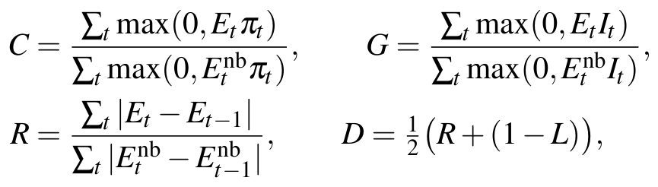 | (1), (2)
where C is the cost, G the carbon emissions, R the ramping and 1−L the mean monthly value of 1 − Ē / max E relative to no battery. Exports are not paid. As the clipping applies to the entire district, one building's export can offset another's import. All KPIs are ratios relative to the no-battery run, hence, values below one are improvements.
The score of a district d is S_{d}=(C+G+D)/3. The first phase of the challenge ranked entries by (C+G)/2 on the training buildings and is called the Phase I score. The final phase ranked them by a public score 0.4 S_{train} + 0.6 S_{val}. The winners were chosen by a private score 0.2 S_{train} + 0.3 S_{val} + 0.5 S_{test} [13]. The public score is the main evaluation metric.

IV. PROPOSED METHODOLOGY
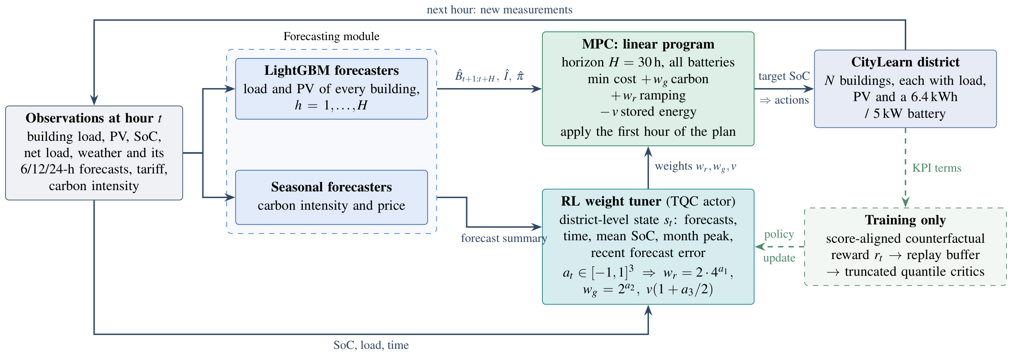
Fig. 1. Architecture of the proposed RL-tuned MPC. The next H hours are predicted by the forecasters every hour. Three weights of a linear program are set by the RL agent from a district-level state, and only the first hour of the plan is applied to the batteries. The dashed parts are used only during training.
Every hour, the controller in Fig. 1 makes predictions for the next H = 30 hours, and the RL agent assigns three weights from a district-level state. A linear programming problem, referred to as the solver, uses those weights to make plans for all batteries over the horizon.

A. Forecasting Module
For each hour, the loads and PV power generation, the carbon intensity, and the price in the next H hours are forecast. For each quantity, there is one LightGBM model [24] which works at all horizons and buildings. Its features include recent and lagged values, the average value of the same hour in the past week, the calendar, the current weather, and the predicted weather of the environment at the target hour. Each value feature is normalized with the mean absolute value of the same feature of the building in the past week, so that the model that is trained using certain buildings can be used for others. The district model is trained using the data from the other two districts, and Optuna [25] selects the parameters of the model via cross-validation. The carbon intensity is predicted as the weighted average of the previous day's and the past week's same hour plus the current error with the decay factor of 0.8^{h}, and the price as the tariff of the same hour in the previous week.

B. Receding-Horizon Linear Program
The forecast net load of the district B̂_{h} (load minus PV), the prices π̂_{h} and the carbon intensities Î_{h} are given to the MPC, which then solves
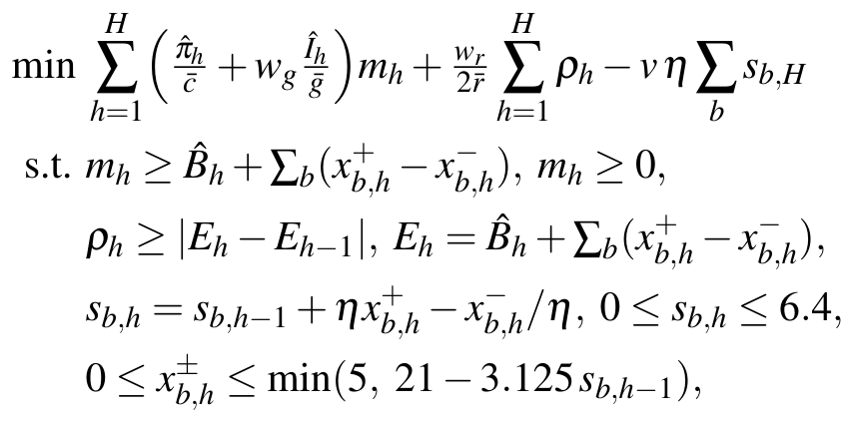 | (3)
where m_{h} is the district import (exports are not paid), ρ_{h} the ramp, s_{b,h} the energy stored in battery b, and x±_{b,h} the charge and discharge powers. These powers are limited to 5 kW, and the efficiency is η=√0.9 each way. This final constraint represents the power taper that CityLearn applies once a battery has passed 80% of its charge. The running no-battery means c̄, ḡ and r̄ put cost, carbon emissions and ramping on the scale of the KPIs. v denotes the median cost per unit over the horizon, and it values the energy left at its end. Only the first hour of the schedule is used. Then the problem is re-solved after another hour (Fig. 2). Using HiGHS, each problem is solved in approximately 20 ms.
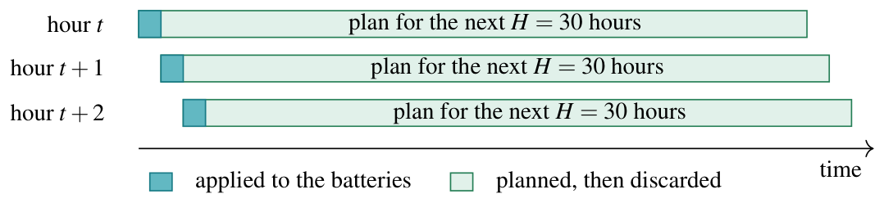
Fig. 2. Receding horizon. A plan for the next 30 hours is made every hour with new forecasts and weights, and only the first hour is applied.

C. Reinforcement Learning Weight Tuner
Since fixed weights in (3) cannot adjust themselves to seasonal changes, forecast quality, or battery state, an RL agent produces three scalars a_{t} ∈ [−1,1]³ per hour. They set the ramp weight w_{r} = 2· 4ª₁, the carbon weight w_{g} = 2ª₂ and the end-of-horizon value v(1 + a₃/2). Each of the weights is centered around a reasonable fixed value. So a zero action reproduces a fixed-weight MPC. The agent's state contains the forecasts of net load, carbon intensity and price over the horizon, the time of day and season, the mean state of charge, the current load and month peak, and the latest forecast error. All of them are independent of the number of buildings. Thus, a policy trained on five buildings can control the seven test buildings as well.
The agent is trained with a score-aligned counterfactual reward. Its terms are built to add up exactly to the numerators of the official KPIs, on the same scale. The district's clipped cost and emissions and its ramp at hour t are
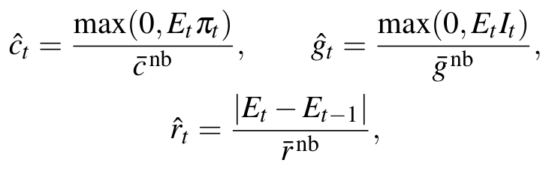 | (4)
where a bar denotes the mean of the term per step in the no-battery run. Hence Σ_{t} ĉ_{t} = T· C, so the return over a year is a linear function of the KPIs. The peak term p̂_{t} is the rise of the running daily maximum of E_{t}. The full load is counted in the first hour of each day, so the terms of a day add up to that day's peak. The wear term is b̂_{t} = Σ_{i} |SoC_{i,t}−SoC_{i,t−1}|. The reward is
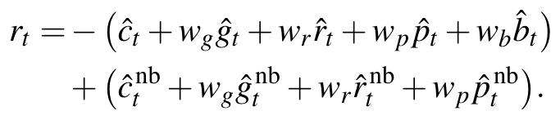 | (5)
The second bracket contains the same terms if the batteries were kept idle during that hour. As it depends only on external data, and not on the actions or the battery's state, it does not affect the optimal policy [20]. However, it does reduce a major part of the variation caused by demand. In this way, the agent gets the reward for the improvement it causes, whereas a reward equal to zero would mean “as good as no battery”. An actual system can calculate the baseline online based on the measured net load and power of the battery.
The weights are chosen according to the score S=(C+G+(R+1−L)/2)/3. The cost gets weight 1, ramping and peak w_{r} = w_{p} = 0.5 (peak accounts for the load factor), wear w_{b} = 0.1, and carbon w_{g} = 2. Hence, it puts extra weight on emissions. The learning algorithm used is TQC [18]. It contains one actor and two distributional critics. Both critics have 25 quantiles (from which 2 highest are excluded when the target is formed). This limits the overestimation caused by a noisy, long-horizon reward.

V. EXPERIMENTAL SETUP
The tuner is trained for 100,000 environment steps or 11.4 years simulated, on the five buildings used for training, using a learning rate of 3·10⁻⁴, a replay buffer size of 200,000 transitions, and a batch size of 256. τ=0.005, γ=0.99, 1 gradient step per environment step, 1,000 warm-up steps and auto-tuning of entropy are used in the experiments. The actor and each critic have two hidden layers with 64 nodes each. Five seeds (42, 100, 2026, 7 and 1234) are run and the mean and standard deviation are reported.
This trained policy is run deterministically on each district for the entire year without retraining. Since CityLearn 2.1.2 includes all 17 buildings, the KPIs and public-private score are calculated using the official scoring formulas, and not the challenge's evaluator. The baselines are no battery, in which case all KPIs will be equal to one, and the rule-based controller (RBC) provided by CityLearn. For the ablations, one part of the controller is replaced at a time: fixed weights in place of the tuner (ramp weight 3, carbon weight 1, horizon 24 hours), 24 hours and 36 hours horizon, default LightGBM hyperparameters, seasonal load and PV predictions, SAC instead of TQC, and a TQC agent with the same reward that sets the battery rates directly. It uses past-only history and 200,000 environment steps. Each RL ablation is run on three seeds (42, 100 and 2026). The fixed-weight controller has no training and is deterministic.

VI. RESULTS

A. Performance Across Districts
The controller is evaluated on all three districts in Table I, with every indicator normalised by the no-battery case. On buildings 1–5, the cost is lowered by 34.4%, carbon emissions by 22.1%, and the district load is smoothed (R = 0.822, 1−L = 0.973, D = 0.898). The RBC performs worse than no batteries on every KPI, which shows that simple rules are not sufficient for this problem. A similar score to training is obtained on the validation district (S = 0.778 on training and 0.771 on validation). Therefore, the policy is not overfitted to the buildings on which it was trained. Fewer improvements are obtained on the seven test buildings (S = 0.913, with cost reduced by 20.1% and emissions by 4.1%). The standard deviation across seeds is at most 0.005.
TABLE I
The proposed RL-tuned MPC in each district, relative to no battery (lower is better). The values are the mean of five seeds, with ± the standard deviation for the scores.
District | Controller | C | G | D | Phase I | S
Train (1–5) | No battery | 1.000 | 1.000 | 1.000 | 1.000 | 1.000
 | RBC | 1.070 | 1.193 | 1.075 | 1.132 | 1.113
 | RL-tuned MPC | 0.656 | 0.779 | 0.898 | 0.718±.001 | 0.778±.002
Validation (6–10) | RL-tuned MPC | 0.654 | 0.755 | 0.903 | 0.705 | 0.771±.002
Test (11–17) | RL-tuned MPC | 0.799 | 0.959 | 0.980 | 0.879 | 0.913±.005
Phase III public score 0.4 S_{train}+0.6 S_{val} |  |  |  |  | 0.774 ± 0.002
Phase III private score 0.2 S_{train}+0.3 S_{val}+0.5 S_{test} |  |  |  |  | 0.843 ± 0.003

B. Analysis of the Learned Policy
The learned policy is first analysed through the mean diurnal profile in the training district (Fig. 3). With no batteries, the district exports up to 5.2 kW of PV at midday, which is not paid, and imports up to 6.6 kW in the evening. The PV surplus is stored in the batteries. The mean state of charge rises from 3.6% at 06:00 to 86.9% at 14:00. The batteries then discharge through the peak tariff from 16:00 to 21:00 and into the night, which gives a flatter load at the grid connection. However, on some days, the controller charges from the grid in the last off-peak hour before the peak tariff. These short import spikes add little to C (cost) and G (carbon) but raise the ramping and the monthly peak, which is the main reason why D is the weakest KPI of the controller.
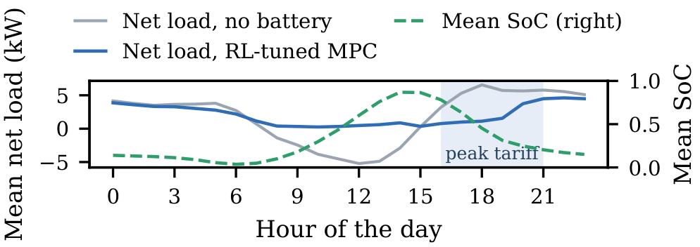
Fig. 3. Mean diurnal profile over the year on the training buildings (seed 42). The district net load is shown with and without batteries, along with the mean state of charge.

C. Ablation Study
Table II presents the effect of changing one component at a time. The largest degradation is caused by the removal of the linear program. When the battery charging and discharging rates are set directly by an RL agent trained with the same reward, a score of S = 0.862 is obtained on buildings 1–5. Only a public score of 0.854 is reached, even with history features and training steps doubled. Ramping is also increased beyond the no-battery level (R = 1.15, D = 1.06). At a 24 h horizon, the RL weight tuner is compared with fixed weights. With the tuner, public and private scores of 0.774 and 0.842 are obtained, against 0.781 and 0.846 with fixed weights. The Phase I score is also improved from 0.742 (fixed weights) to 0.723 (tuner), mainly because the cost is reduced from C = 0.703 to C = 0.666.
The benefit of the weight tuner depends on the forecast accuracy. With seasonal load and PV forecasts at a 24 h horizon, the Phase I score is improved from 0.744 with fixed weights to 0.732 with the tuner. This gain is obtained mainly through a lower cost, with C reduced from 0.697 (fixed weights) to 0.670 (tuner). However, it is offset by a weaker grid KPI, with D increased from 0.934 (fixed weights) to 0.967 (tuner). As a result, no gain in the public score is obtained, with 0.807 (fixed weights) and 0.808 (tuner). The private score is degraded from 0.856 (fixed weights) to 0.864 (tuner). The LightGBM hyperparameters are then tuned, which raises the PV forecast accuracy from about 90% to 96%. The public score is lowered from 0.782 to 0.774 by this tuning. Much smaller effects are produced by the horizon and the RL algorithm. Public scores within 0.003 of each other are obtained with horizons of 24, 30 and 36 hours, and a score of 0.775 ± 0.001 is obtained when TQC is replaced by SAC. These differences are comparable to the variation across seeds.
TABLE II
Ablations of the RL-tuned MPC, one change at a time (lower is better). The proposed method uses five seeds and the other RL variants use three, while the fixed-weight controller is deterministic.
Variant | Phase I | S_{train} | S_{val} | S_{test} | Public | Private
Proposed (TQC, tuned LightGBM, 30 h) | 0.718 | 0.778 | 0.771 | 0.913 | 0.774 | 0.843
Fixed weights instead of RL tuning, 24 h | 0.742 | 0.784 | 0.779 | 0.910 | 0.781 | 0.846
Without linear program (RL sets battery rates) | 0.763 | 0.862 | 0.849 | – | 0.854 | –
Seasonal load and PV forecasts, 24 h | 0.732 | 0.810 | 0.806 | 0.920 | 0.808 | 0.864
Untuned LightGBM, 24 h | 0.722 | 0.787 | 0.779 | 0.908 | 0.782 | 0.845
Horizon 24 h | 0.723 | 0.779 | 0.771 | 0.909 | 0.774 | 0.842
Horizon 36 h | 0.719 | 0.780 | 0.773 | 0.915 | 0.776 | 0.846
SAC instead of TQC (36 h) | 0.715 | 0.778 | 0.772 | 0.915 | 0.775 | 0.845

D. Comparison with the Challenge Leaderboards
The Phase III public leaderboard [8] reports the C, G and D of each entry as a 0.4/0.6 weighted combination of the training and validation districts. On this leaderboard, a score of 0.774 is obtained by the proposed method, which corresponds to 8th place among the 42 entries (Fig. 4). This score lies between the seventh and eighth entries, at 0.767 and 0.789. The lowest carbon score of all 42 entries is achieved, at 0.764. This value is about 5% below the best published carbon score of 0.803, and it is achieved on each of the five seeds. The cost score of 0.655 ranks 4th. The difference from the first-placed entry is caused by the grid KPI, where D = 0.901 ranks 13th and the first-placed entry reaches D = 0.738.
The private leaderboard, on which the seven test buildings were added and the winners were decided, was never published. Only the medians of the participants are reported [13], namely C = 0.792, G = 0.940, D = 0.996 and a score of 0.907. With the same weights (0.2, 0.3 and 0.5), C = 0.727, G = 0.862, D = 0.940 and a score of 0.843 are obtained, and all of these values are better than the medians. On the Phase I leaderboard, the best entries score 0.631, 0.635 and 0.651, and the score of 0.718 corresponds to 5th place.
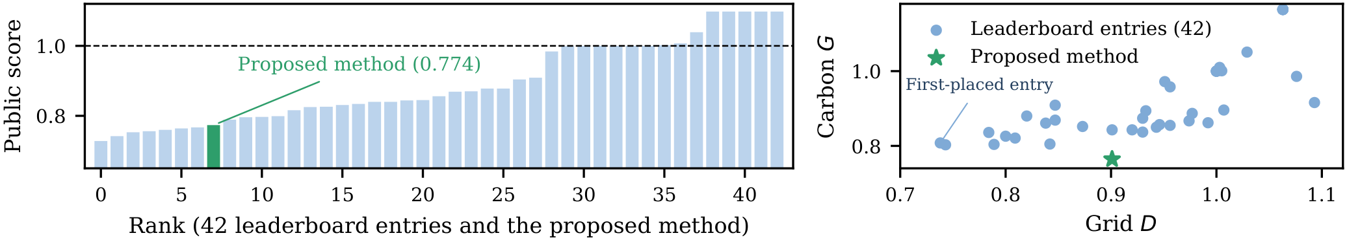
Fig. 4. The proposed method among the 42 entries of the Phase III public leaderboard. The public scores are shown in rank order on the left (dashed line: no battery), and the carbon KPI against the grid KPI on the right. No entry achieves lower emissions, but most of the top-ranked entries achieve a lower grid KPI.

E. Limitations of Load Forecasting
The load is by far the most difficult quantity to predict. With LightGBM, the hourly load of a single building is 50–59% predictable (one minus the mean absolute error divided by the mean load), only slightly above the seasonal rule. The district total is more predictable, at 71–78%, because the random variations of individual buildings partly cancel out. This total determines the grid KPIs and the clipped cost and emissions.
To identify which forecast errors degrade the score, the fixed-weight controller is given the true future values for one part of its forecasts at a time (Fig. 5). This diagnostic test provides an upper bound on the gain from better forecasts. With its own forecasts, the controller scores S = 0.784 in the training district and S = 0.779 in the validation district. Perfect PV forecasts barely change S (0.782 and 0.776). Perfect load forecasts lower S to 0.648 in both districts, well below the public score of 0.728 of the first-placed entry. Most of this gain comes from the district total over the next few hours. Rescaling the building forecasts to the true total gives S = 0.649 and 0.648, and the true load for only the next six hours gives S = 0.659 and 0.651. The performance of the controller is therefore limited mainly by the accuracy of the hourly district-load forecast, rather than by the solver or the tuner.
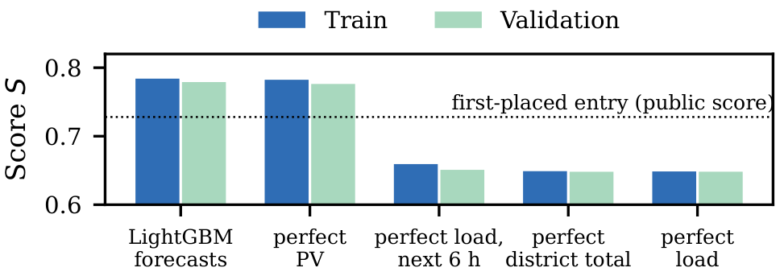
Fig. 5. Score of the fixed-weight controller when one part of its forecasts is replaced by the true future (upper bound). The dotted line marks the public score of the first-placed entry.

VII. DISCUSSION
In the proposed design, RL has more relevance as a tuner of the optimiser rather than as a control mechanism. The predictions along with the linear program give the daily trends of prices, PV and demand and the physics of the batteries. The agent's three actions only adjust a schedule that already satisfies the battery constraints. Hence, the credit assignment problem over the thousands of hourly battery decisions becomes much easier. This also explains why removing the solver is much costlier (public 0.854) than removing the tuner (0.781). There are two fixes for the weaker grid KPI: a load factor term in the linear program and improved predictions of the district total that Section VI-E identifies as the primary source of error.
One of the limitations of this study is that only one climate zone and one year of data with five training buildings are used. Also, the KPIs are calculated using the official formula on CityLearn 2.1.2 but not with the challenge evaluator, and each RL ablation uses only three seeds. Besides the results, the research achieves several United Nations Sustainable Development Goals (SDGs), listed in Table III.
TABLE III
United Nations Sustainable Development Goals addressed by this work.
SDG | Justification
SDG 13 (Climate Action) | Reduces CO₂ emissions by 22%, the lowest carbon score of all leaderboard entries.
SDG 7 (Affordable and Clean Energy) | Reduces electricity costs by about one-third and stores the rooftop PV surplus.
SDG 11 (Sustainable Cities and Communities) | Coordinates the batteries of a district and smooths the grid load.
SDG 9 (Industry, Innovation and Infrastructure) | Shows an AI control design for smart energy infrastructure.
SDG 12 (Responsible Consumption and Production) | Shifts consumption toward lower-price, lower-carbon hours.

VIII. CONCLUSION
This work presented an RL-tuned model predictive controller where predictions from the LightGBM model drive a receding-horizon linear programming problem and the TQC agent adjusts its weights every hour. In the CityLearn 2022 challenge, the controller achieved 34.4% reduction in electricity cost and 22.1% reduction in the emission in the training district. Across five seeds, it obtained a public score of 0.774 ± 0.002 and a private score of 0.843 ± 0.003, ranking 8th on the public leaderboard. It has the best carbon score among 42 competitors. In contrast to the champion solution, the controller obtains a worse grid KPI score, and the analysis reveals that this is due mainly to the quality of prediction of the district load. With perfect load predictions, the same solver will achieve approximately 0.65.

REFERENCES
[1] J. R. Vázquez-Canteli and Z. Nagy, “Reinforcement learning for demand response: A review of algorithms and modeling techniques,” Appl. Energy, vol. 235, pp. 1072–1089, 2019.
[2] Z. Wang and T. Hong, “Reinforcement learning for building controls: The opportunities and challenges,” Appl. Energy, vol. 269, p. 115036, 2020.
[3] R. S. Sutton and A. G. Barto, Reinforcement Learning: An Introduction, 2nd ed. MIT Press, 2018.
[4] L. Yu et al., “A review of deep reinforcement learning for smart building energy management,” IEEE Internet Things J., vol. 8, no. 15, pp. 12 046–12 063, 2021.
[5] Z. Nagy et al., “Ten questions concerning reinforcement learning for building energy management,” Build. Environ., vol. 241, p. 110435, 2023.
[6] J. R. Vázquez-Canteli, J. Kampf, G. Henze, and Z. Nagy, “CityLearn v1.0: An OpenAI Gym environment for demand response with deep reinforcement learning,” in Proc. ACM Int. Conf. Syst. Energy-Efficient Build., Cities, Transp. (BuildSys), 2019, pp. 356–357.
[7] K. Nweye et al., “CityLearn v2: Energy-flexible, resilient, occupant-centric, and carbon-aware management of grid-interactive communities,” J. Build. Perform. Simul., 2024.
[8] CityLearn Challenge Organizers, “The NeurIPS 2022 CityLearn challenge,” AIcrowd, https://www.aicrowd.com/challenges/neurips-2022-citylearn-challenge, 2022.
[9] G. Dulac-Arnold et al., “Challenges of real-world reinforcement learning: Definitions, benchmarks and analysis,” Mach. Learn., vol. 110, no. 9, pp. 2419–2468, 2021.
[10] J. R. Vázquez-Canteli, G. Henze, and Z. Nagy, “MARLISA: Multi-agent reinforcement learning with iterative sequential action selection for load shaping of grid-interactive connected buildings,” in Proc. ACM Int. Conf. Syst. Energy-Efficient Build., Cities, Transp. (BuildSys), 2020, pp. 170–179.
[11] K. Nweye, B. Liu, P. Stone, and Z. Nagy, “Real-world challenges for multi-agent reinforcement learning in grid-interactive buildings,” Energy and AI, vol. 10, p. 100202, 2022.
[12] J. B. Rawlings, D. Q. Mayne, and M. M. Diehl, Model Predictive Control: Theory, Computation, and Design, 2nd ed. Nob Hill Publishing, 2017.
[13] K. Nweye et al., “The CityLearn challenge 2022: Overview, results, and lessons learned,” in Proc. NeurIPS 2022 Competitions Track, ser. PMLR, vol. 220, 2023.
[14] T. P. Lillicrap et al., “Continuous control with deep reinforcement learning,” in Proc. Int. Conf. Learn. Represent. (ICLR), 2016.
[15] S. Fujimoto, H. van Hoof, and D. Meger, “Addressing function approximation error in actor-critic methods,” in Proc. Int. Conf. Mach. Learn. (ICML), ser. PMLR, vol. 80, 2018, pp. 1587–1596.
[16] T. Haarnoja, A. Zhou, P. Abbeel, and S. Levine, “Soft actor-critic: Off-policy maximum entropy deep reinforcement learning with a stochastic actor,” in Proc. Int. Conf. Mach. Learn. (ICML), ser. PMLR, vol. 80, 2018, pp. 1861–1870.
[17] J. Schulman, F. Wolski, P. Dhariwal, A. Radford, and O. Klimov, “Proximal policy optimization algorithms,” arXiv preprint arXiv:1707.06347, 2017.
[18] A. Kuznetsov, P. Shvechikov, A. Grishin, and D. Vetrov, “Controlling overestimation bias with truncated mixture of continuous distributional quantile critics,” in Proc. Int. Conf. Mach. Learn. (ICML), ser. PMLR, vol. 119, 2020, pp. 5556–5566.
[19] A. Raffin et al., “Stable-Baselines3: Reliable reinforcement learning implementations,” J. Mach. Learn. Res., vol. 22, no. 268, pp. 1–8, 2021.
[20] A. Y. Ng, D. Harada, and S. Russell, “Policy invariance under reward transformations: Theory and application to reward shaping,” in Proc. Int. Conf. Mach. Learn. (ICML), 1999, pp. 278–287.
[21] J. Cao et al., “Deep reinforcement learning-based energy storage arbitrage with accurate lithium-ion battery degradation model,” IEEE Trans. Smart Grid, vol. 11, no. 5, pp. 4513–4521, 2020.
[22] P. Henderson et al., “Deep reinforcement learning that matters,” in Proc. AAAI Conf. Artif. Intell., 2018.
[23] R. Agarwal, M. Schwarzer, P. S. Castro, A. Courville, and M. G. Bellemare, “Deep reinforcement learning at the edge of the statistical precipice,” in Adv. Neural Inf. Process. Syst. (NeurIPS), vol. 34, 2021.
[24] G. Ke et al., “LightGBM: A highly efficient gradient boosting decision tree,” in Adv. Neural Inf. Process. Syst. (NeurIPS), vol. 30, 2017.
[25] T. Akiba, S. Sano, T. Yanase, T. Ohta, and M. Koyama, “Optuna: A next-generation hyperparameter optimization framework,” in Proc. ACM SIGKDD Int. Conf. Knowl. Discov. Data Min., 2019, pp. 2623–2631.

